# Tile and icon asset generator for UWP apps

The tile and icon asset generator provides a set of Adobe Photoshop actions and templates that you can use to generate the 68 recommended app assets that follow our [Windows 10 tile and icon asset guidelines](https://msdn.microsoft.com/en-us/library/windows/apps/mt412102.aspx).

## Requirements

* Adobe Photoshop CC 2015

## Installation

1. Download the Tile and icon asset generator zip file from <link>, if you haven’t already. Extract the zip file to the location of your choice. The zip file contains several files:
   * This readme
   * Two Photoshop action files: one for the Mac and one for Windows:
     + Windows UWP v1.2 for Mac.atn
     + Windows UWP v1.2 for Windows.atn
   * A templates directory that contains 7 files:
     + Logo-AppList.psd
     + Logo-NoMargins.psd
     + Logo-TileLargeMedium.psd
     + Logo-TileSmall.psd
     + Logo-TileWide.psd
     + SplashScreen.psd
     + StoreLogo.psd
2. Launch Adobe Photoshop.
3. Locate the Actions window. If you don’t see it, here’s how to enable it: In the main menu, select **Window** > **Actions**. (Alternatively, you can press Alt + F9.)  
   The Actions Window appears:

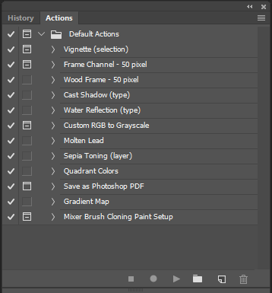

1. Click the hamburger menu in the upper-right corner of the Actions window and select **Load actions...**

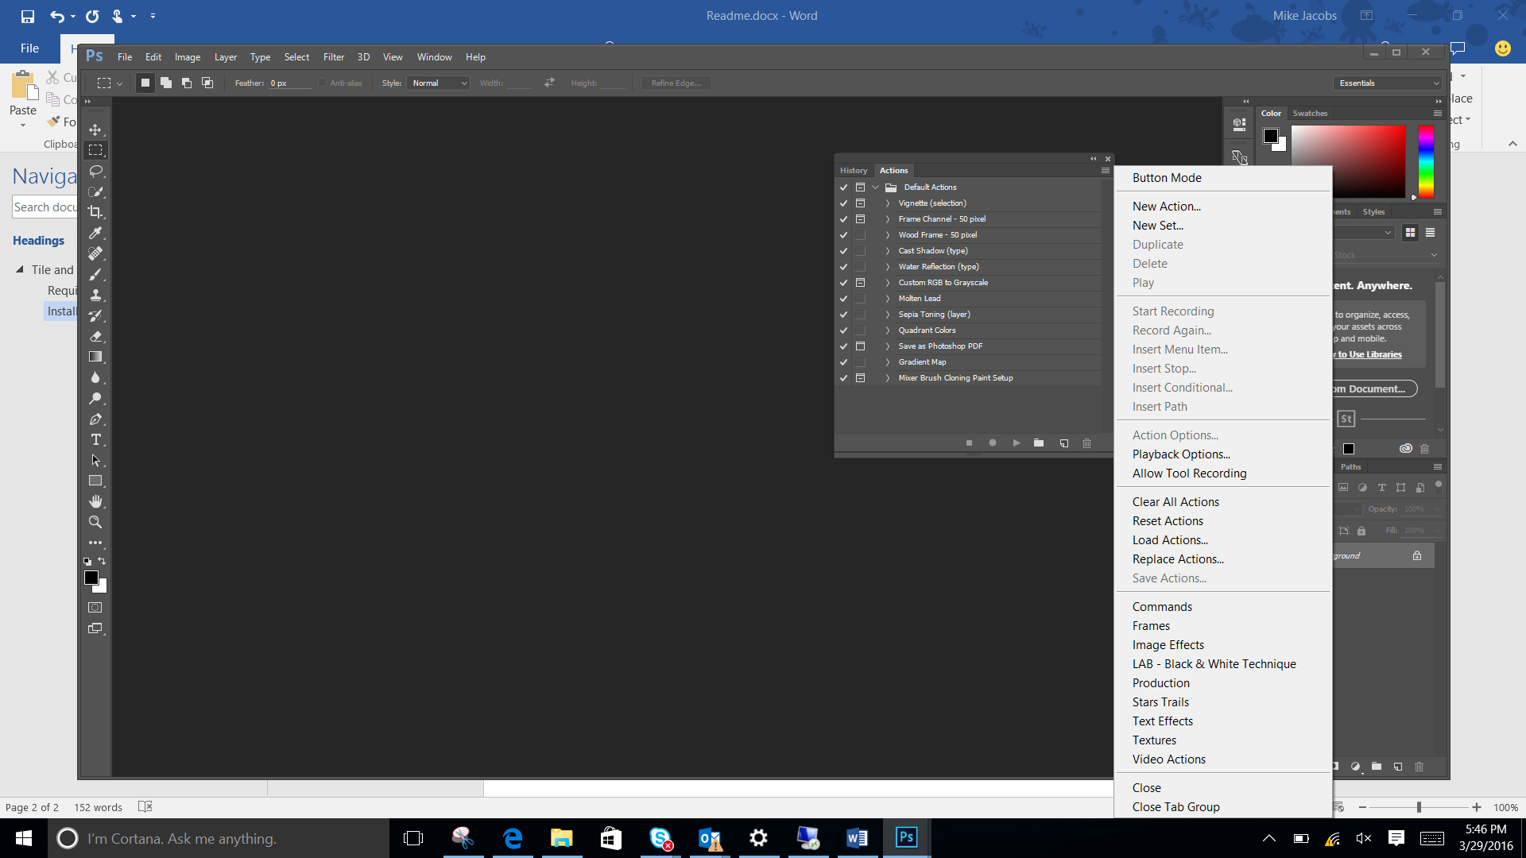

A file dialog appears.

1. Navigate to the location where you extracted the Tile and icon asset generator and select the appropriate ATN file for your operating system:
   * + For Macs, use Windows UWP v1.2 for Mac.atn
     + For Windows, use Windows UWP v1.2 for Windows.atn

The Windows UWP 1.2 actions appear in the Actions window.  
  
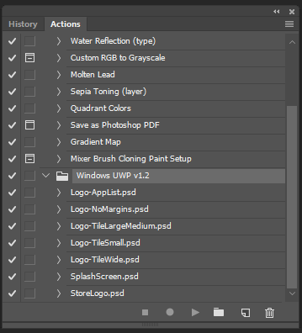

1. Create a directory to contain the generated images:
   * On Windows, create a C:\images directory.
   * If you’re using Photoshop for Mac, images will go to the /var/tmp/ folder. That folder isn’t visible in Finder (the file explorer), because it’s hidden by default. To navigate to it, use Cmd+Shift+G and manually type the path.

Now you’re ready to start generating assets.

## Usage

The tile and icon asset generator includes 7 template files: , one for each tile and icon asset type:

* + - Logo-AppList.psd
    - Logo-NoMargins.psd
    - Logo-TileLargeMedium.psd
    - Logo-TileSmall.psd
    - Logo-TileWide.psd
    - SplashScreen.psd
    - StoreLogo.psd

Each template file contains rulers representing all the recommended boundaries (based on our [Windows 10 guidelines for tile and icon assets](https://msdn.microsoft.com/en-us/library/windows/apps/mt412102.aspx)).

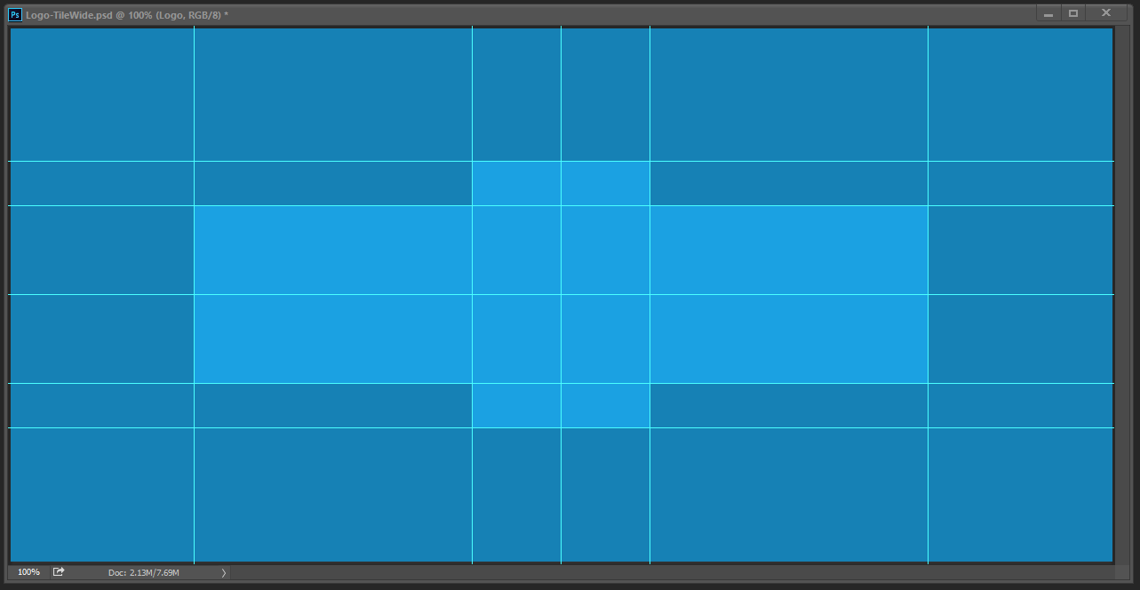

In pretty much all cases, it’s recommended that you keep your logo confined to the middle 4 boxes.

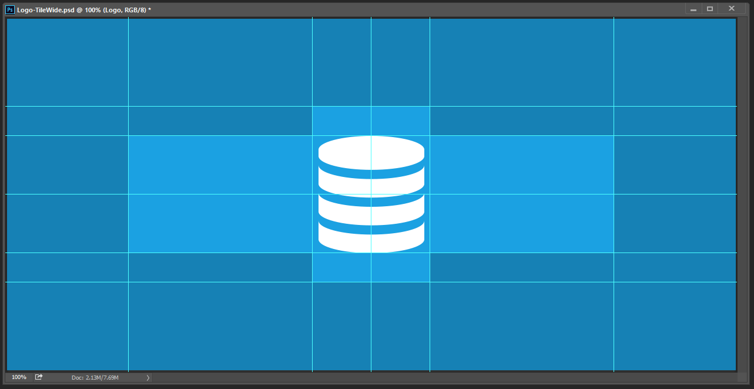

However, if your logo is wide, you can use the 2 square areas to the left and right of the center 4. Or, if your logo is tall, you can use the 2 square areas above and below the center 4.

Sticking to these boundaries will ensure your logo looks great everywhere within Windows. Unless you intend to have full bleed branding on your assets, which in that case you can ignore the rulers.

For the best image quality, we recommend using a vector-based image for your logo, so that it can be re-sized without compromising its quality.

1. Open one or more of the Photoshop template files, one for each asset that you want to create.
2. Edit the template file, adhering to the boundaries (unless you want a full-bleed asset).
3. For each Photoshop template file, run the corresponding Photoshop Action (i.e. Run the Logo-TileLargeMedium.psd action on the Logo-TileLargeMedium.psd template file).  
   [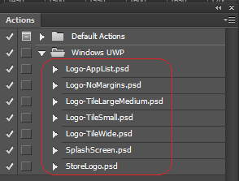](https://msdnshared.blob.core.windows.net/media/MSDNBlogsFS/prod.evol.blogs.msdn.com/CommunityServer.Blogs.Components.WeblogFiles/00/00/00/61/32/0250.5.png)  
     
   Photoshop generates the image assets and copies them to the output folder:
   * On Windows: Photoshop outputs to the C:\images directory.
   * If you’re using Photoshop for Mac, images will go to the /var/tmp/ folder. That folder isn’t visible in Finder (the file explorer), because it’s hidden by default. To navigate to it, use Cmd+Shift+G and manually type the path.
4. If you’re generating the square44x44logo (Logo-NoMargins.psd), used for the taskbar, task switcher, and start menu jump list, Photoshop generates two sets of images: plated and unplated versions:  
     
   

* If you want un-plated, simply include all the asset images named “Square44x44Logo.targetsize-##_altform-unplated.png” in your solution and ensure your tile background color is set to transparent.
* If you want them to be plated, then include the “Square44x44Logo.targetsize-##.png” image files and specify a hex value for tile color in the app manifest which dictates the background color for the tiles and icons. No need to include both sets.

1. Copy the image files from the output folder to your Assets folder within your W10 application project.
2. Ensure each file you want is included in your Visual Studio project and set as Content so that it can be deployed with the application.
3. Update the Visual Assets tab in the application manifest to point to the appropriate image assets set. If you type in the name of the file without the “.scale-###.” part of the file name, it’ll automatically figure out each scaled image available in the project and show up in the manifest designer. For example, instead of selecting each image one by one for each scale size, just type in Square71x71Logo.png and it’ll populate the 100, 125, 150, 200, and 400 scale images.

[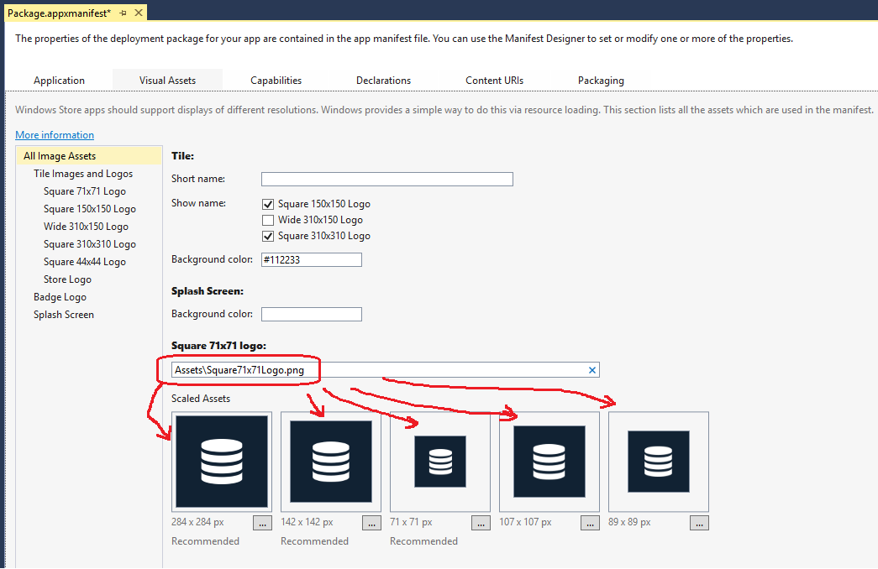](https://msdnshared.blob.core.windows.net/media/MSDNBlogsFS/prod.evol.blogs.msdn.com/CommunityServer.Blogs.Components.WeblogFiles/00/00/00/61/32/0804.8.png)

You’re done!